`


IT342-G4
System Integration and Architecture

System Design Document (SDD)

Project Title: MediStream
Prepared By: Rabe, Pranz Nicole Cañete

Version: 2.0
Date: 05/29/26
Status: Final

REVISION HISTORY TABLE
Version | Date | Author | Changes Made | Status
1.0 | 02/18/26 | Rabe, Pranz Nicole C. | Initial draft from handwritten notes | Draft
2.0 | 03/03/26 | Rabe, Pranz Nicole C. | Revised and enhanced entire document | Revised
3.0 | 05/29/26 | Rabe, Pranz Nicole C. | Finalized the entire document | Final

TABLE OF CONTENTS
Contents
EXECUTIVE SUMMARY 4
1.0 INTRODUCTION 5
2.0 FUNCTIONAL REQUIREMENTS SPECIFICATION 5
3.0 NON-FUNCTIONAL REQUIREMENTS 9
4.0 SYSTEM ARCHITECTURE 11
5.0 API CONTRACT & COMMUNICATION 12
6.0 DATABASE DESIGN 17
7.0 UI/UX DESIGN 18
8.0 PLAN 21

EXECUTIVE SUMMARY
1.1 Project Overview
MediStream is a patient queue and consultation management system designed for small clinics and barangay health centers to digitally manage patient registration, queues, and basic consultation notes. The system streamlines patient flow, reduces manual errors, and allows doctors and staff to easily track patient history for prior visits.

1.2 Objectives
- Develop a web-based and mobile-based patient queue and consultation management system for outpatient clinics.
- Digitize patient registration and medical staff management.
- Implement real-time patient queue tracking with status transitions.
- Enable doctors and nurses to record and review consultation notes.
- Improve operational efficiency and patient experience in small health centers.

1.3 Scope
Included Features:
- Patient Management: Add, edit, delete, and view patient profiles.
- Doctor/Nurse Management: Add, edit, delete, and view staff.
- Patient Queue System: Status transitions (Waiting, Consulting, Done).
- Consultation Notes: Recording symptoms, diagnosis, medicine, and remarks.

Excluded Features:
- In-patient admission and ward management.
- Billing, payments, and insurance processing.
- Advanced medical analytics and reporting.
- SMS/Email notifications to patients.

1.0 INTRODUCTION
1.1 Purpose
This document serves as the comprehensive design specification for the MediStream MVP system. It provides detailed requirements, architectural decisions, API contracts, database design, and implementation roadmap to guide development and ensure all components integrate seamlessly.

2.0 FUNCTIONAL REQUIREMENTS SPECIFICATION
2.1 Project Overview
Project Name: MediStream
Domain: Healthcare / Outpatient Clinic Management
Primary Users: Staff/Receptionist, Doctor/Nurse, Patients
Problem Statement: Small clinics and barangay health centers rely heavily on manual queues and paper records, leading to inefficiencies, misplaced records, and difficulty tracking patient history.
Solution: A lightweight system that manages patient queues, consultation notes, and visit history while remaining simple, affordable, and easy to use.
2.2 Core User Journeys
Journey 1: New Patient Self-Registration and Queueing
- Patient visits clinic website or kiosk
- Clicks "Join Queue"
- Fills registration form:
- First and Last Name
- Age
- Gender
- Contact Number
- Address (optional)
- Clicks "Submit"
- System creates a new Patient record with a unique `patient_id`.
- System automatically generates a Queue Number (e.g. `Q-001`) with "Waiting" status.
- System displays: "Registration Successful! Your Queue Number: Q-042" along with the generated Patient ID.
- Patient receives the Queue Number and Patient ID on screen.
- Patient can screenshot or write down queue information and wait for their turn in the waiting area.
Journey 2: Consultation Process (Doctor)
- Doctor logs into the system with email and password.
- Views the Queue Dashboard containing all active queue numbers.
- Selects a waiting patient to call.
- System automatically:
- Sets the patient's status from "Waiting" to "Consulting".
- Auto-populates Patient Information (Name, Age, Gender) and current consultation details (current date, logged-in doctor's name).
- Doctor reviews patient details and enters:
- Symptoms
- Diagnosis
- Prescription (Medicine Prescribed)
- Remarks (Optional)
- Doctor clicks "Save Consultation". The system:
- Saves the consultation record linked to the patient's medical history.
- Clears the patient from the active queue.
- Updates the dashboard list.
Journey 3: Queue Display Monitoring (Patients in Waiting Area)
- Patients watch the clinic TV monitor or public queue URL (`/QueueDashboard`).
- The display updates in real-time.
- When a doctor accepts the next consultation, the patient sees their queue number move to the "Now Serving" panel with the assigned room or doctor.
- When a consultation is finished, that queue number is removed or marked "Done".
Journey 4: Staff Login (Doctor/Nurse/Admin)
- Staff member navigates to staff login page
- Enters work email
- Enters password
- Clicks "Login"
- System verifies credentials and role
- Redirects to role-appropriate dashboard:
- Doctor: Can access all system features with Consultation Dashboard.
- Nurse: Can access all system features except the Consultation Dashboard and consultation form (Doctor-only area).
- Admin: Full access including Staff Management
- Staff begins daily tasks
Journey 5: Staff Logout
- Staff member clicks logout button on the bottom of the sidebar
- System ends current session
- Redirects to staff login page
- Displays "Logged out successfully" message
Journey 6: Staff Views Own Profile (All Staff)
- Logged-in staff clicks the profile/settings section.
- Views and edit their details (Staff ID, name, email, contact, department, specialty).
- Staff can upload/update their profile picture.
Journey 8: Admin Edits Staff Profile (Admin Only)
- Admin views the Staff Management Dashboard.
- Clicks "Add Staff" to register a new staff member account.
- Clicks "Edit" to update editable fields of any staff member (including Role, Department, Specialty, Availability).
- Admin can choose to Delete a staff member. The system performs a Hard Delete from the repository, removing both the staff profile and its associated credentials while preserving the historical audit trail in consultations (which reference a string doctor name).

2.3 Feature List (MoSCoW)
MUST HAVE
- User authentication (register, login, logout)
- Patient Management (Create, Read, Update, and Delete for patient profiles)
- Real-time Patient Queue ("Waiting", "Consulting", and "Done")
- Consultation Logging (Digital recording of symptoms, diagnosis, medicine, and remarks.)
- Medical Staff Management (Create, Read, Update, and Delete for staff profiles)
SHOULD HAVE
- Patient Search
- Visit History
- Basic input validation feedback
- Responsive design for all screen sizes
COULD HAVE
- Printable Summaries
- Appointment Scheduling
- Multi-Language UI
WON'T HAVE
- Real payment processing
- Email notifications
- In-patient Admission
- Advanced analytics
- Automated Notifications
2.4 Detailed Feature Specifications
Feature: User Authentication
- Screens: Registration, Login, Forgot Password
- Fields: Email, Password, Confirm Password
- Validation: Email format, password strength, uniqueness
- API Endpoints: POST /api/auth/register, POST /api/auth/login, POST /api/auth/logout
- Security: JWT tokens for session management and password hashing.
Feature: Patient Management
- Screens: Patient List, Patient Registration, Patient Profile.
- Display: Table or list view of registered patients with names and IDs.
- Search: Search by patient name or ID to retrieve visit history.
- API Endpoints: GET /patients, GET /patients/{id}, GET /patients/all
- Admin Functions: POST /patients/add, PUT /patients/update/{id}, DELETE /patients/delete/{id}
Feature: Queue Management
- Screens: Queue Dashboard
- Functions: Automatically add registered patient to queue, update status (Waiting, Consulting, Done).
- Persistence: Real-time database storage for active queue order.
- API Endpoints: GET /api /queue, PUT /api/queue/{id}, DELETE /api/queue/{id}
Feature: Consultation Logging
- Screens: Consultation Form
- Data Collected: Symptoms, Diagnosis, Medicine, and Remarks.
- Process: Select patient from queue, validate input fields, save notes to history, clear from active queue.
- API Endpoints: POST /consultations/add, GET /consultations/all/{id}, PUT /consultations/update/{id}, DELETE /consultations/delete/{id}
Feature: Staff Management (Admin Panel)
- Screens: Staff Management Dashboard
- Functions: Add/edit/delete medical staff (Doctors/Nurses) or receptionists.
- Access Control: Admin role required
- API Endpoints: POST /api/medicalstaff/add, GET /api/medicalstaff/all, GET /api/medicalstaff/{id}, PUT /api/medicalstaff/update{id}, DELETE /api/medicalstaff/{id}
2.5 Acceptance Criteria
Authentication & Account Management
AC-1: Successful Staff Registration
- Given I am a new clinic staff member with a valid Staff ID.
- When I enter my Staff ID, work email, first and last name, a strong password, and confirm my password.
- And I click "Register Account".
- Then my account should be successfully created in the system.
- And I should be redirected to the login page with a confirmation message.
- Then the system should validate that the Staff ID exists in the medical_staff records
- And automatically assign the role (Doctor/Nurse/Admin) based on the medical_staff record
- And link the new user account to the existing medical_staff profile
AC-2: Successful Staff Login
- Given I am a registered staff member (Doctor, Nurse/Staff, or Admin).
- When I enter my work email and correct password.
- And I click "Login".
- Then I should be successfully authenticated.
- And I should be redirected the Dashboard

Patient Management & Queueing
AC-3: Patient Registration & Queue Generation
- Given I am a new patient checking in.
- When I fill out the form (First Name, Last Name, Age, Gender, Contact, Address) and submit,
- Then a unique `patient_id` is created, and a new `queue` item with a generated `queueNumber` (e.g. Q-101) and "Waiting" status is saved in the database.
AC-4: Real-Time Queue Display
- Given I am a patient in the waiting area viewing the TV monitor or clinic website.
- When the doctor completes a consultation.
- Then the queue display should update in real-time.
- And I should see:
- Current queue numbers with "Waiting" status
- The number currently being served under "Now Serving"
- Updated queue order as patients move from "Waiting" to "Consulting" to "Done"
Patient Management & Queueing
AC-5: Doctor Initiates Next Consultation
- Given I am a logged-in Doctor viewing the Queue Dashboard.
- When I choose a patient id .
- Then the system should automatically:
- Change patient status from "Waiting" to "Consulting"
- Auto-populate Patient Information (Name, Age, Gender, Doctor name, Current Date)
AC-6: Doctor Documents Consultation
- Given I am a Doctor in an active consultation with a patient.
- When I scroll to the Consultation Details section.
- And I enter Symptoms, Diagnosis, Prescription, and optional Remarks.
- And I click "Save Consultation".
- Then the system should:
- Save complete consultation to patient's Medical History
- Remove patient from active queue
- Increment "Today's Consultations" counter by 1
- Clear Consultation Details fields for next patient
Medical Staff Management
AC-7: Staff Views Own Profile
- Given I am any logged-in staff member (Doctor, Nurse, or Admin).
- When I click on my profile icon.
- Then I should be able to view all my information.
- And I should see options to edit profile or change password.
- And I should NOT be able to edit my Staff ID or Role.
AC-8: Staff Edits Own Profile
- Given I am viewing my own profile.
- When I click "Edit Profile" and update editable fields (name, contact, etc.).
- And I click "Save Changes".
- Then the system should validate my updates (email format, contact format).
- And display "Profile updated successfully" confirmation.
- And my changes should reflect immediately.
AC-9: Admin Edits Staff Profile
- Given I am an Admin viewing any staff profile.
- When I click "Edit" and update any editable field including Role.
- And I click "Save Changes".
- Then the system should display "Staff profile updated successfully".
AC-10: Patient History & Search
- Given I am a Nurse or Staff member.
- When I navigate to Medical History dashboard.
- And I search by Patient ID or Name.
- And I select a patient from results.
- Then I should see a complete Medical History timeline.
- And I should be able to click any entry to expand and view full consultation details (symptoms, diagnosis, prescriptions, date, doctor).

3.0 NON-FUNCTIONAL REQUIREMENTS
3.1 Performance Requirements
- API response time: ≤ 8 seconds for 95% of requests
- Web page load time: ≤ 8 seconds on broadband
- Mobile app cold start: ≤ 8 seconds
- Support 100 concurrent users
- Database queries complete within 500ms
3.2 Security Requirements
- HTTPS for all communications
- JWT token authentication
- Password hashing with bycrypt (salt rounds = 12)
- SQL injection prevention
- Rate limiting: 100 requests/minute per IP
- Role-based Access Control
3.3 Compatibility Requirements
- Web Browsers: Chrome, Firefox, Safari, Edge (latest 2 versions)
- Android: API Level 24+ (Android 7.0+)
- Screen Sizes: Mobile (360px+), Tablet (768px+), Desktop (1024px+)
- Operating Systems: Windows 10+, macOS 10.15+, Linux Ubuntu 20.04+
3.4 Usability Requirements
- Staff should be able to register a new patient and queue them within 2 minutes.
- Consistent navigation across all pages
- Clear error messages with recovery options
- Touch targets minimum 44x44px on mobile

4.0 SYSTEM ARCHITECTURE
4.1 Component Diagram
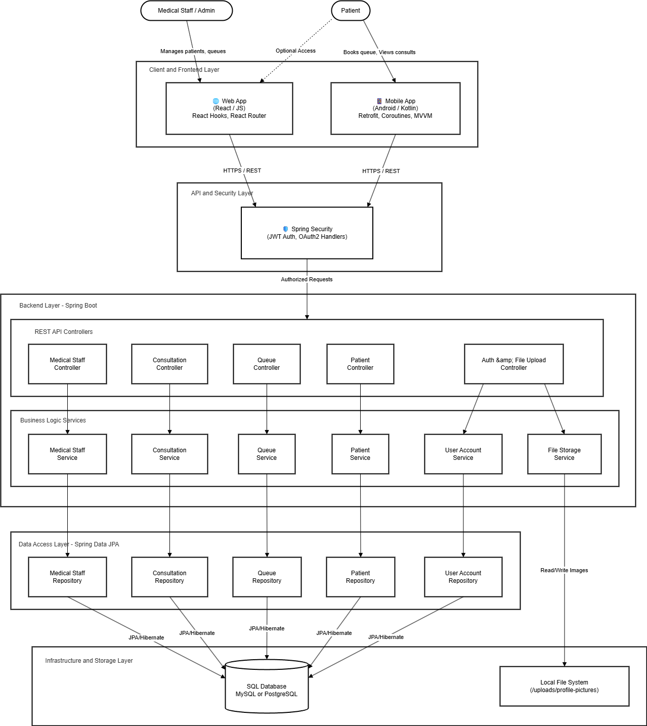
Technology Stack:
- Backend: Java 17, Spring Boot 3.x, Spring Security, Spring Data JPA
- Database: PostgreSQL 14+
- Web Frontend: React 18, React Router DOM v6, Axios, Vanilla CSS, Tailwind CSS.
- Mobile: Kotlin, Jetpack Compose, Retrofit
- Build Tools: Maven (Backend), npm/yarn (Web), Gradle (Android)

5.0 API CONTRACT & COMMUNICATION
5.1 API Standards
Base URL | https://[server_hostname]:[port]/api/v1
Format | JSON for all requests/responses
Authentication | Bearer token (JWT) in Authorization header
Response Structure | {  "success": boolean,  "data": object|null,  "error": {  "code": string,  "message": string,  "details": object|null  },  "timestamp": string  }

5.2 Endpoint Specifications

Authentication Endpoints

User Registration
Description | User Registration
API URL | /api/auth/register
HTTP Request Method | POST
Format | JSON for all requests/responses
Authentication | None
Request Payload | {  "firstName": "<firstName>",  "lastName": "<lastName>",  "email": "<email>",  "password": "<password>",  "staffId": "<staffId>"  }
Response Structure | {  "success": true,  "message": "Registration successful",  "token": "<jwt>",  "user": {  "id": <accountID>,  "email": "<email>",  "role": "<role>",  "username": "<email>",  "firstName": "<firstName>",  "lastName": "<lastName>", "medicalStaff": { ... }  }  }

User Login
Description | User Login
API URL | /api/auth/login
HTTP Method | POST
Format | JSON for all requests/responses
Authentication | None
Request Payload | {  “email”: <email>,  “password”: <password>,  }
Response Structure | {  "success": true,  "message": "Login successful",  "token": "<jwt>",  "user": { ... } // same structure as registration's user map  }

Auth Check - Email Exists
Description | Check if email already exists
API URL | /api/auth/check-email/{email}
HTTP Method | GET
Format | JSON (boolean)
Authentication | None
Request Payload | None (path param: email)
Response Structure | true | false

Create User Account
Description | Add a UserAccountEntity
API URL | /api/useraccount/add
HTTP Method | POST
Format | JSON
Authentication | None
Request Payload | {  "username": "<email>",  "passwordHash": "<hashedPassword>", "role": "<role>"  }
Response Structure | {  "accountID": <int>,  "username": "<email>",  "passwordHash": "<...>",  "role": "<role>"  }

List All User Accounts
Description | Get all user accounts
API URL | /api/useraccount/all
HTTP Method | GET
Format | JSON
Authentication | None
Request Payload | None
Response Structure | [ { UserAccountEntity }, ... ]

Get User Account By ID
Description | Get account by ID
API URL | /api/useraccount/{id}
HTTP Method | GET
Format | JSON
Authentication | None
Request Payload | None (path param: id)
Response Structure | {  "accountID": <int>,  "username": "<email>",  "role": "<role>"  }

Get Current User
Description | Returns authenticated user's summary
API URL | /api/useraccount/current
HTTP Method | GET
Format | JSON
Authentication | None
Request Payload | None
Response Structure | {  "accountID": <int>,  "username": "<email>",  "role": "<role>",  "staffID": <int>,  "name": "<name>",  "medicalRole": "<role>",  "specialty": "<specialty>",  "contactNo": "<contactNo>",  "department": "<department>",  "age": <int>,  "gender": "<gender>"  }

Change Password
Description | Change user password
API URL | /api/useraccount/change-password
HTTP Method | POST
Format | JSON
Authentication | None
Request Payload | {  "username": "<email>",  "currentPassword": "<currentPassword>",  "newPassword": "<newPassword>",  "accountID": <int>  }
Response Structure | 200 OK: "Password changed successfully"  400/401 on validation failure or incorrect password

Update User Account
Description | Update account fields
API URL | /api/useraccount/update/{id}
HTTP Method | PUT
Format | JSON
Authentication | None
Request Payload | UserAccountEntity JSON
Response Structure | 200 OK: updated UserAccountEntity

Delete User Account
Description | Delete account
API URL | /api/useraccount/delete/{id}
HTTP Method | DELETE
Format | JSON / plain text
Authentication | None
Request Payload | None
Response Structure | "User account with ID {id} has been deleted."

Create Patient
Description | Add PatientEntity
API URL | /patients/add
HTTP Method | POST
Format | JSON
Authentication | None
Request Payload | {  "fname": "<firstName>",  "lname": "<lastName>",  "age": <int>,  "gender": "<gender>",  "contactNo": "<contactNo>",  "address": "<address>"  }
Response Structure | {  "patientId": <int>,  "fname": "<firstName>",  "lname": "<lastName>",  "age": <int>,  "gender": "<gender>",  "contactNo": "<contactNo>",  "address": "<address>"  }

List All Patients
Description | Get all patients
API URL | /patients/all
HTTP Method | GET
Format | JSON
Authentication | None
Request Payload | None
Response Structure | [ { PatientEntity }, ... ]

Get Patient By ID
Description | Get patient details
API URL | /patients/{id}
HTTP Method | GET
Format | JSON
Authentication | None
Request Payload | None
Response Structure | 200 OK: PatientEntity or 404 Not Found

Update Patient
Description | Update patient by id
API URL | /patients/update/{id}
HTTP Method | PUT
Format | JSON
Authentication | None
Request Payload | PatientEntity JSON
Response Structure | 200 OK: updated PatientEntity

Delete Patient
Description | Delete patient by id
API URL | /patients/delete/{id}
HTTP Method | DELETE
Format | JSON / plain text
Authentication | None
Request Payload | None
Response Structure | String message from service

Create Medical Staff
Description | Add MedicalStaffEntity
API URL | /api/medicalstaff/add
HTTP Method | POST
Format | JSON
Authentication | None
Request Payload | {  "name": "<name>",  "role": "<role>",  "contactNo": "<contactNo>",  "specialty": "<specialty>",  "age": <int>,  "gender": "<gender>",  "department": "<department>",  "userAccount": { ... } // optional link  }
Response Structure | {  "staffID": <int>,  "name": "<name>",  "role": "<role>",  "contactNo": "<contactNo>",  "specialty": "<specialty>",  "age": <int>,  "gender": "<gender>",  "department": "<department>",  "availability": "<availability>"  }

List All Medical Staff
Description | Get all medical staff
API URL | /api/medicalstaff/all
HTTP Method | GET
Format | JSON
Authentication | None
Request Payload | None
Response Structure | [ { MedicalStaffEntity }, ... ]

Get Medical Staff By ID
Description | Get staff by ID
API URL | /api/medicalstaff/{id}
HTTP Method | GET
Format | JSON
Authentication | None
Request Payload | None
Response Structure | 200 OK: MedicalStaffEntity

Update Medical Staff
Description | Update staff record
API URL | /api/medicalstaff/update/{id}
HTTP Method | PUT
Format | JSON
Authentication | None
Request Payload | MedicalStaffEntity JSON
Response Structure | 200 OK: updated MedicalStaffEntity

Delete Medical Staff
Description | Delete staff by id
API URL | /api/medicalstaff/delete/{id}
HTTP Method | DELETE
Format | JSON / plain text
Authentication | None
Request Payload | None
Response Structure | "Medical staff with ID {id} has been deleted."

Join Queue
Description | Add patient to queue (creates patient and queue entry)
API URL | /api/queue/join
HTTP Method | POST
Format | JSON
Authentication | None
Request Payload | {  "firstName": "<firstName>",  "lastName": "<lastName>",  "age": <int>,  "gender": "<gender>",  "contactNo": "<contactNo>",  "address": "<address>"  }
Response Structure | {  "queueNumber": "<queueNumber>",  "patientName": "<fullName>",  "status": "<status>",  }

List All Queue Items
Description | Get all queue entries
API URL | /api/queue
HTTP Method | GET
Format | JSON
Authentication | None
Request Payload | None
Response Structure | {  "id": <long>,  "queueNumber": "<str>",  "status": "<str>",  "arrivalTime": "<str>",  "assignedDoctor": "<str>",  "patient": { PatientEntity }  }

Update Queue Item
Description | Update queue item
API URL | /api/queue/{id}
HTTP Method | PUT
Format | JSON
Authentication | None
Request Payload | Queue JSON
Response Structure | 200 OK: updated Queue object

Delete Queue Item
Description | Delete queue entry
API URL | /api/queue/{id}
HTTP Method | DELETE
Format | JSON
Authentication | None
Request Payload | None
Response Structure | 200 OK:: { "message": "Queue item deleted successfully" } or error message

Create Consultation
Description | Create consultation record (ties to patient & staff)
API URL | /consultations/add
HTTP Method | POST
Format | JSON
Authentication | None
Request Payload | {  "patientId": <int>,  "staffId": <int>,  "symptoms": "<string>",  "diagnosis": "<string>",  "medicinePrescribed": "<string>",  "remarks": "<string>",  "consultationDate": "YYYY-MM-DD"  }
Response Structure | 200 OK: created ConsultationEntity (fields: id, symptoms, diagnosis, medicinePrescribed, remarks, consultationDate, links to patient/staff)

List All Consultations
Description | Get all consultations
API URL | /consultations/all
HTTP Method | GET
Format | JSON
Authentication | None
Request Payload | None
Response Structure | [ { ConsultationEntity }, ... ]

Update Consultation
Description | Update consultation by id
API URL | /consultations/update/{id}
HTTP Method | PUT
Format | JSON
Authentication | None
Request Payload | ConsultationEntity JSON
Response Structure | 200 OK: updated ConsultationEntity

Delete Consultation
Description | Delete consultation by id
API URL | /consultations/delete/{id}
HTTP Method | DELETE
Format | JSON / plain text
Authentication | None
Request Payload | None
Response Structure | String message from service

5.3 Error Handling
HTTP Status Codes
- 200 OK - Successful request
- 201 Created - Resource created
- 400 Bad Request - Invalid input
- 401 Unauthorized - Authentication required/failed
- 403 Forbidden - Insufficient permissions
- 404 Not Found - Resource doesn't exist
- 409 Conflict - Duplicate resource
- 500 Internal Server Error - Server error

6.0 DATABASE DESIGN
6.1 Entity Relationship Diagram
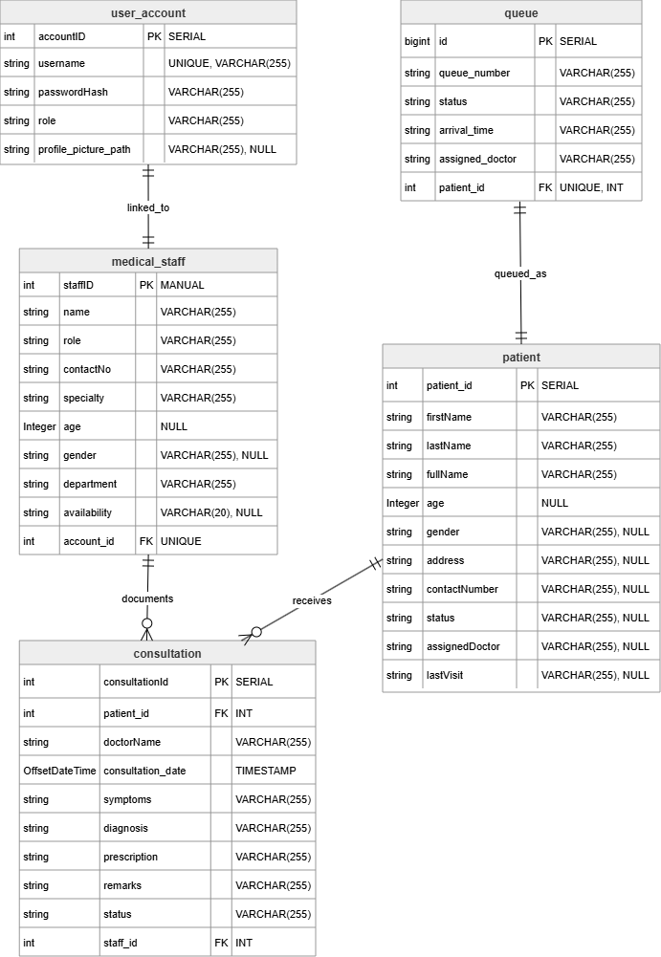
Detailed Relationships:
- One-to-One: UserAccountEntity ↔ MedicalStaffEntity (each user_account may be linked to exactly one medical_staff; MedicalStaffEntity owns the account_id FK).
- One-to-One: Queue ↔ PatientEntity (each queue row references one patient via patient_id).
- One-to-Many: MedicalStaffEntity → ConsultationEntity (a staff member may have many consultations; ConsultationEntity holds staff_id).
- One-to-Many: PatientEntity → ConsultationEntity (a patient may have many consultations; ConsultationEntity holds patient_id).
- Many-to-One: ConsultationEntity → PatientEntity (each consultation references one patient).
- Many-to-One: ConsultationEntity → MedicalStaffEntity (each consultation references one staff member).
Key Tables:
- user_account – User accounts and authentication (UserAccountEntity)
- medical_staff – Medical staff profiles linked to accounts (MedicalStaffEntity)
- patient – Patient demographic profiles and current tracking status (PatientEntity)
- consultation – Consultation records, clinical documentations, and historical visit outcomes (ConsultationEntity)
- queue – Active patient queue management records (Queue)
- visit_history – Generic visitor logs and entry tracking (VisitHistory)
Table Structure Summary:

Table Structure Summary

user_account (UserAccountEntity)
- accountID int PK "SERIAL" — Unique primary identifier for the account.
- username string "UNIQUE, VARCHAR(255)" — System credential name.
- passwordHash string "VARCHAR(255)" — Securely hashed authorization password.
- role string "VARCHAR(255)" — Explicit application permission role.
- profile_picture_path string "VARCHAR(255), NULL" — Pointer reference to storage destination.

medical_staff (MedicalStaffEntity)
- staffID int PK "MANUAL" — Custom identifier designated for staff assignment.
- name string "VARCHAR(255)" — Full presentation identity string.
- role string "VARCHAR(255)" — Clinical designation or tier.
- contactNo string "VARCHAR(255)" — Direct contact connection details.
- specialty string "VARCHAR(255)" — Professional area of specific clinical focus.
- age Integer "NULL" — Calculated lifespan numerical index.
- gender string "VARCHAR(255), NULL" — Staff gender marker value.
- department string "VARCHAR(255)" — Primary operational ward tracking.
- availability string "VARCHAR(20), NULL" — Operational working schedule block flags.
- account_id int FK "UNIQUE" — Directly binds 1:1 down to target user_account(accountID).

patient (PatientEntity)
- patient_id int PK "SERIAL" — Automatic unique tracking value.
- firstName string "VARCHAR(255)" — Given legal identity string.
- lastName string "VARCHAR(255)" — Inherited family identity value.
- fullName string "VARCHAR(255)" — Aggregated whole text sequence representation.
- age Integer "NULL" — Documented lifespan metric tracking.
- gender string "VARCHAR(255), NULL" — Clinical assignment tracking marker.
- address string "VARCHAR(255), NULL" — Registered localization residence profile data.
- contactNumber string "VARCHAR(255), NULL" — Registered telecom outreach link.
- status string "VARCHAR(255), NULL" — Operational monitoring metrics flag.
- assignedDoctor string "VARCHAR(255), NULL" — Literal snapshot of handling staff label.
- lastVisit string "VARCHAR(255), NULL" — General descriptive tracking trace log parameter.

consultation (ConsultationEntity)
- consultationId int PK "SERIAL" — Auto-increment tracking block index.
- patient_id int FK "INT" — Binds directly to the specific patient(patient_id).
- doctorName string "VARCHAR(255)" — Logged literal title text value of the provider.
- consultation_date OffsetDateTime "TIMESTAMP" — Structured timezone-aware time mapping.
- symptoms string "VARCHAR(255)" — Patient presentation intake diagnostic notes.
- diagnosis string "VARCHAR(255)" — Confirmed objective medical findings entry string.
- prescription string "VARCHAR(255)" — Assigned medication schema and delivery directions.
- remarks string "VARCHAR(255)" — General ancillary clinician case descriptions.
- status string "VARCHAR(255)" — State value tracking.
- staff_id int FK "INT" — Binds directly to authoring source via medical_staff(staffID).

queue (Queue)
- id bigint PK "SERIAL" — Scaled unique sequential reference mapping item index.
- queue_number string "VARCHAR(255)" — Presentable display code identification token.
- status string "VARCHAR(255)" — Instant state indicators tracking pipeline steps.
- arrival_time string "VARCHAR(255)" — Initialized check-in chronological trace tracker.
- assigned_doctor string "VARCHAR(255)" — Plain text string value tracking assigned team target.
- patient_id int FK "UNIQUE, INT" — Maps uniquely 1:1 onto target pipeline occupant patient(patient_id).

visit_history (VisitHistory)
- id bigint PK "SERIAL" — Large-scale distinct transactional database key tracker.
- visitor_name string "VARCHAR(255)" — Raw profile identification string tracking access.
- visit_time string "VARCHAR(255)" — Raw descriptive timestamps notation capture field.
- purpose string "VARCHAR(255)" — Reason or scope statement logging entry access.

7.0 UI/UX DESIGN
7.1 Web Application Wireframes
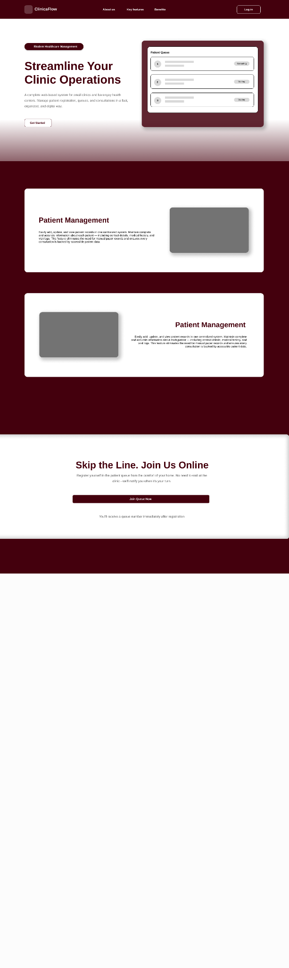
Landing Page
Sign up
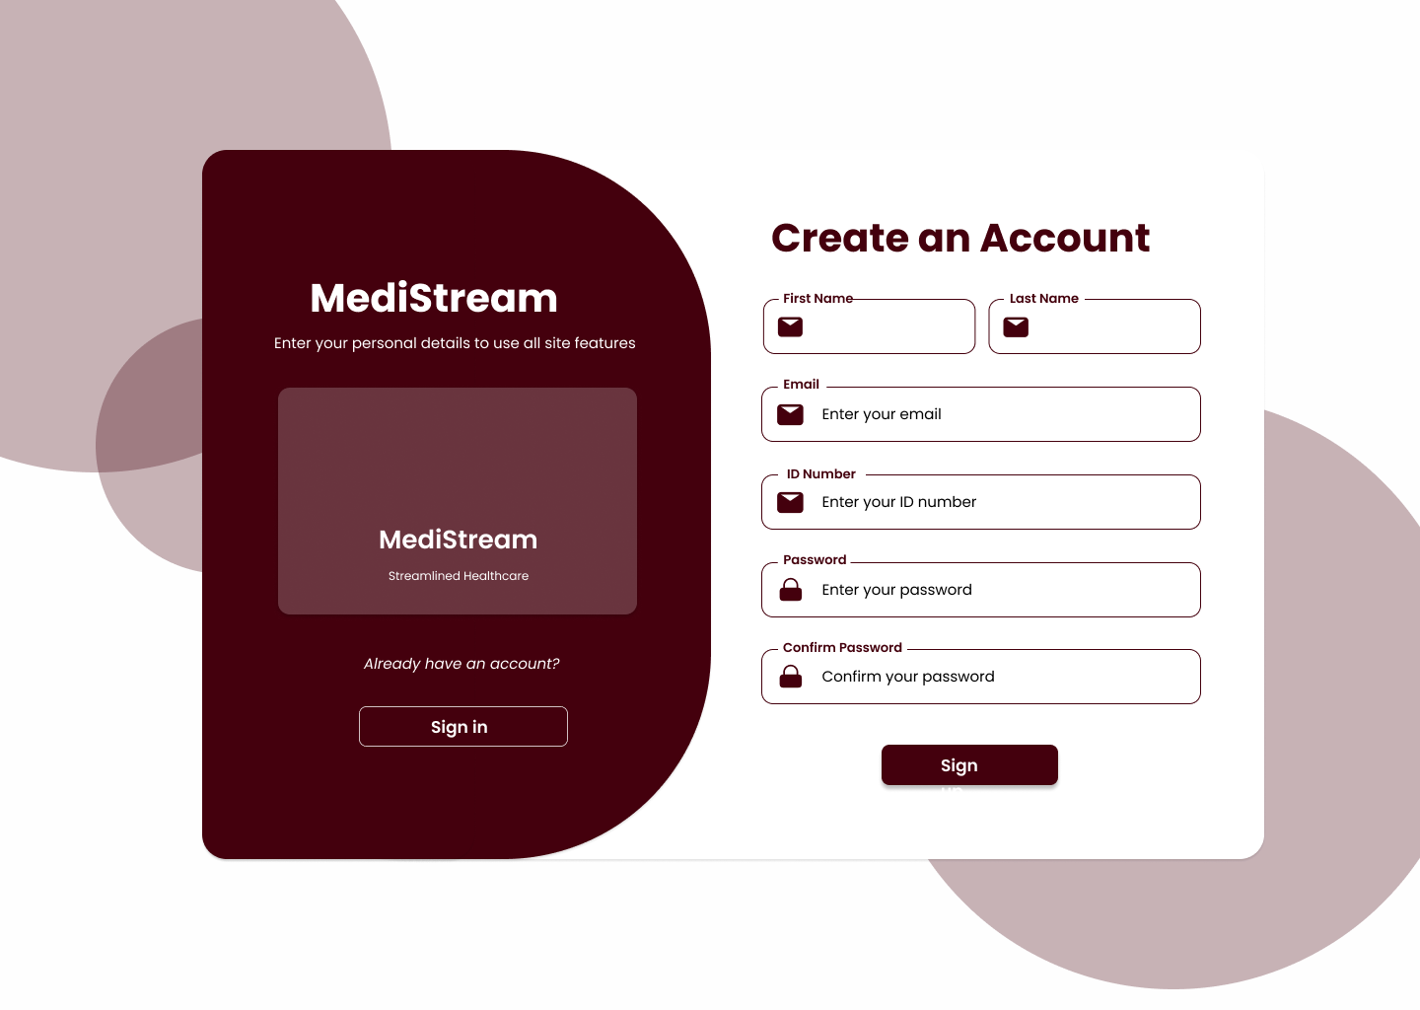
Sign in
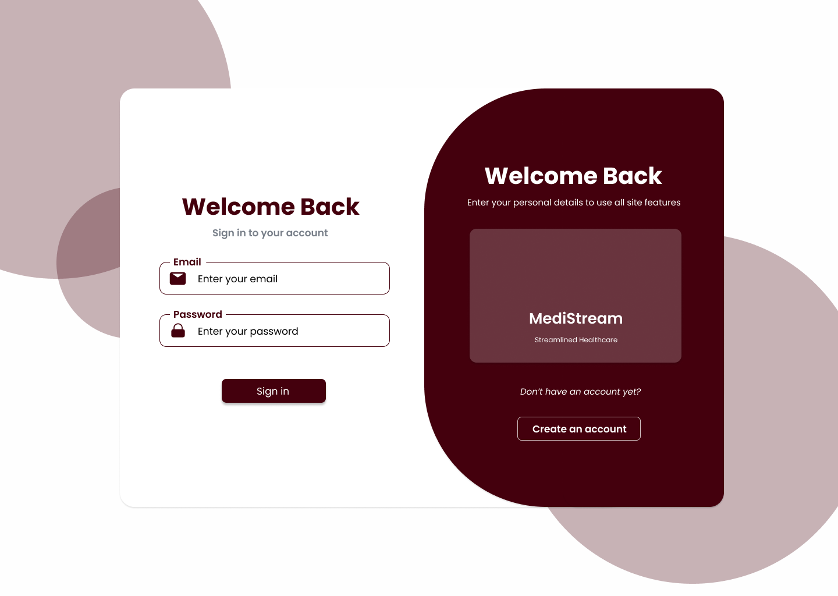
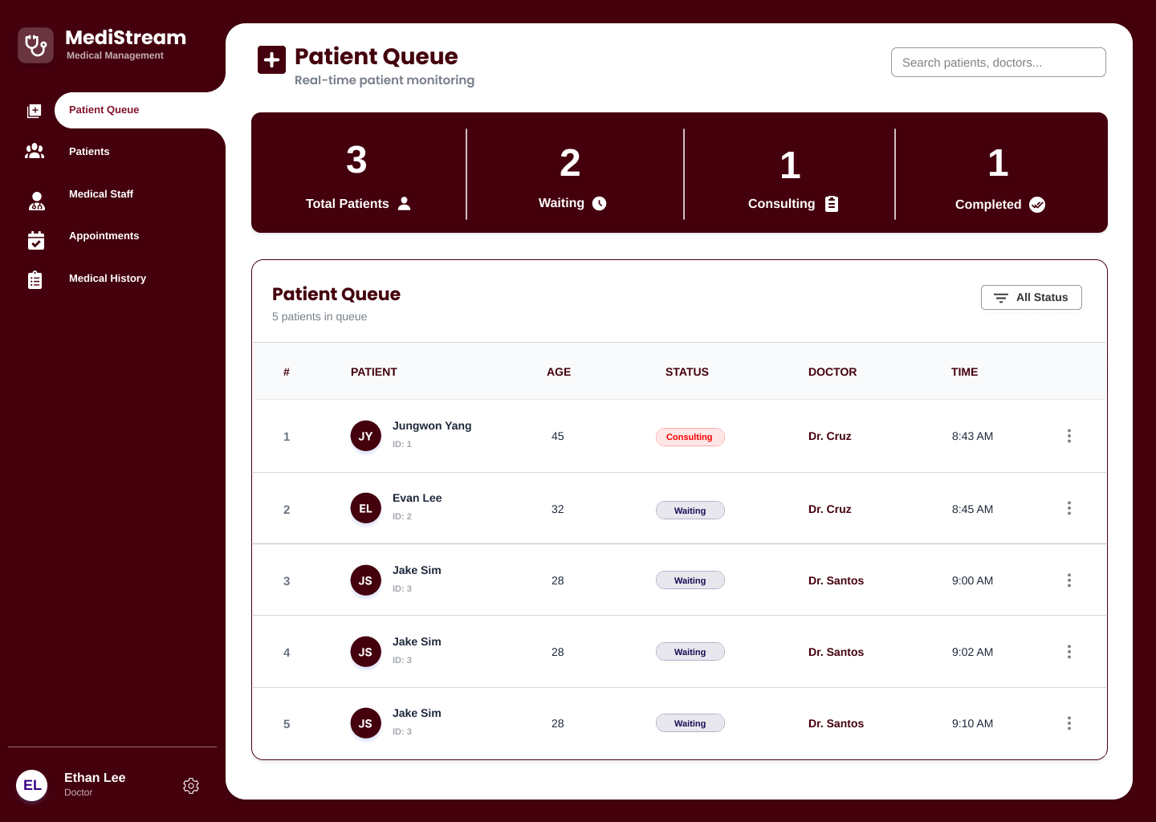
Patient Queue Dashboard (Staff side)
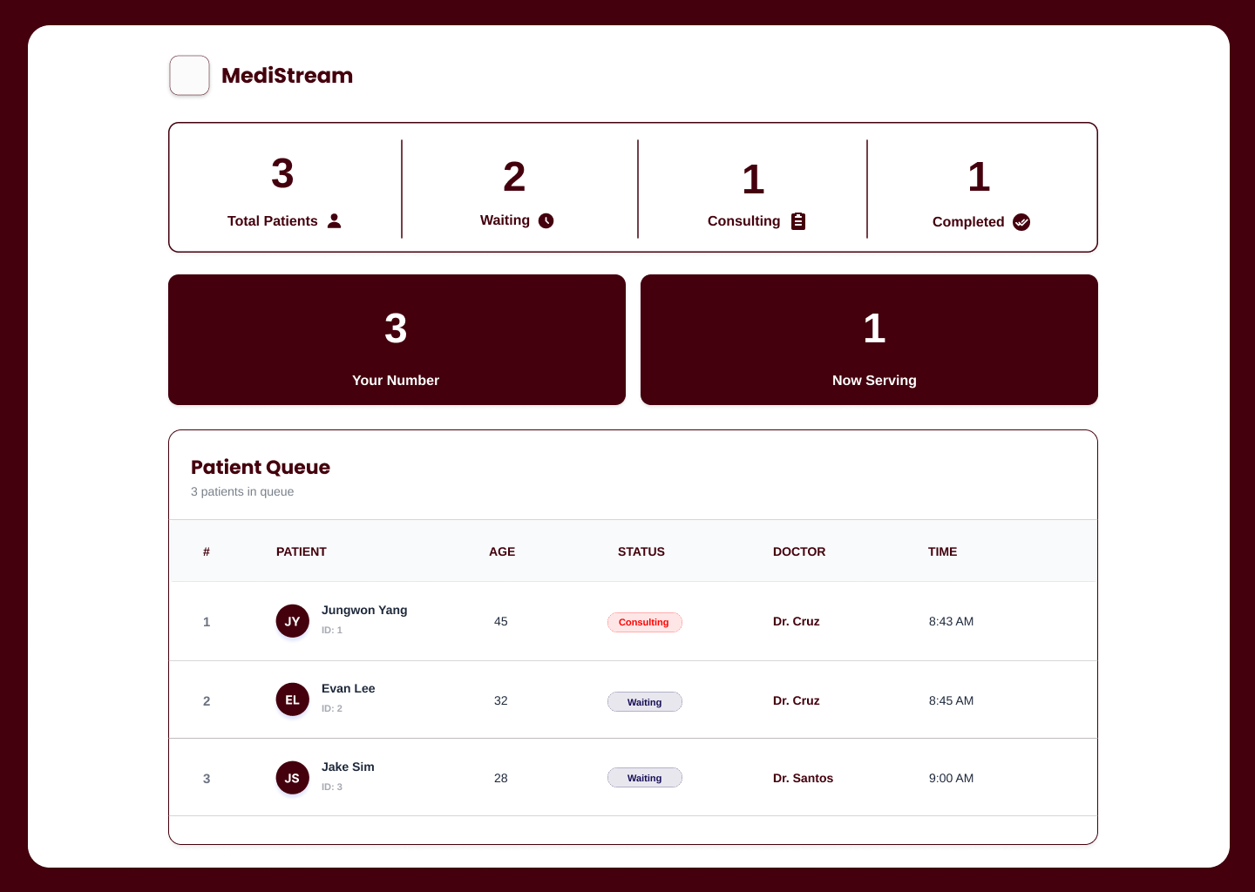
Patient Queue Dashboard (Patient side)
Patient Records

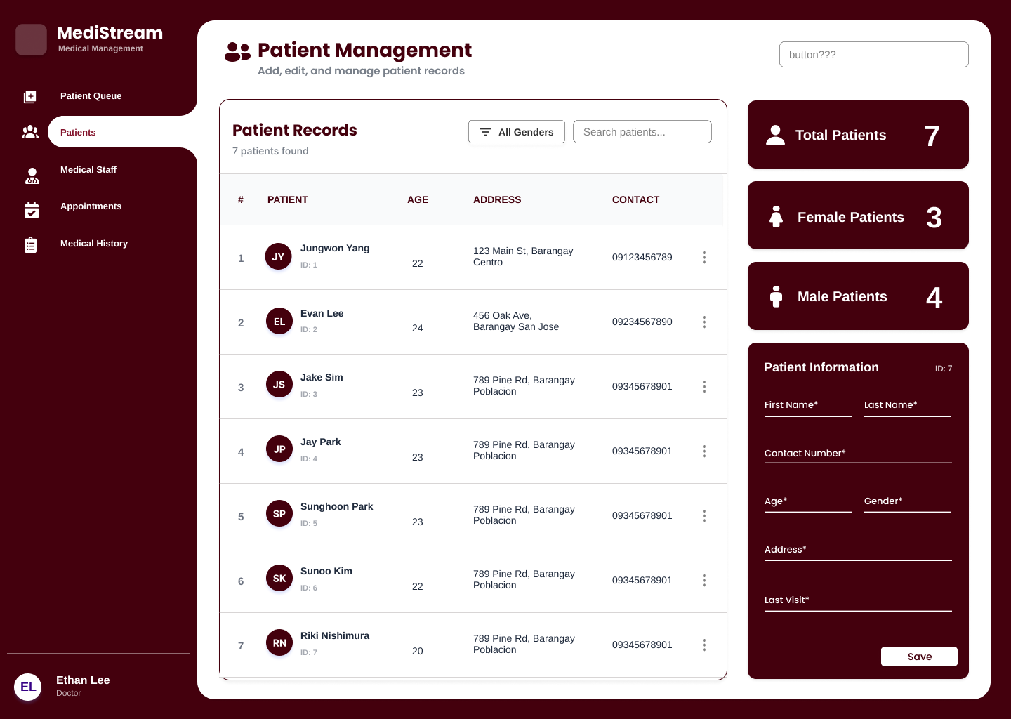
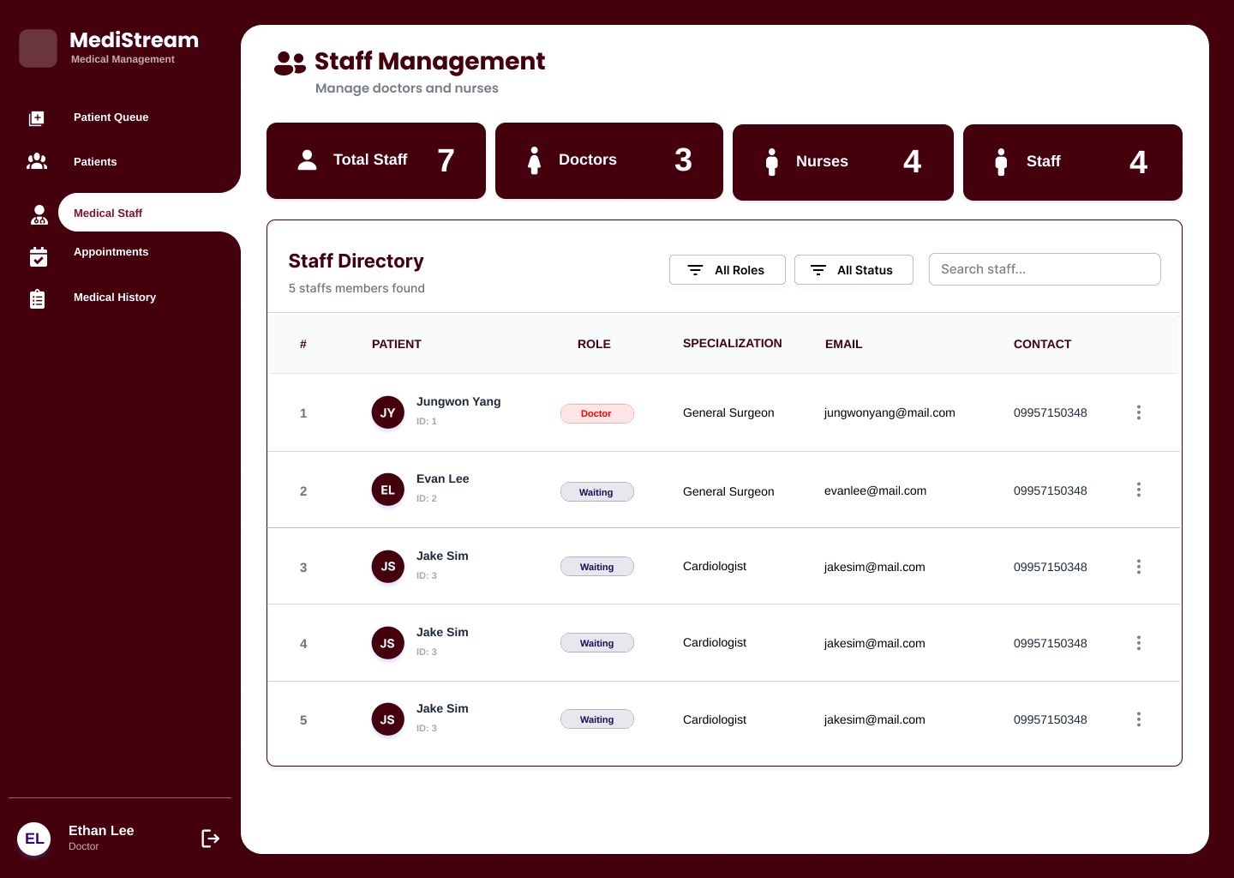
Staff Records
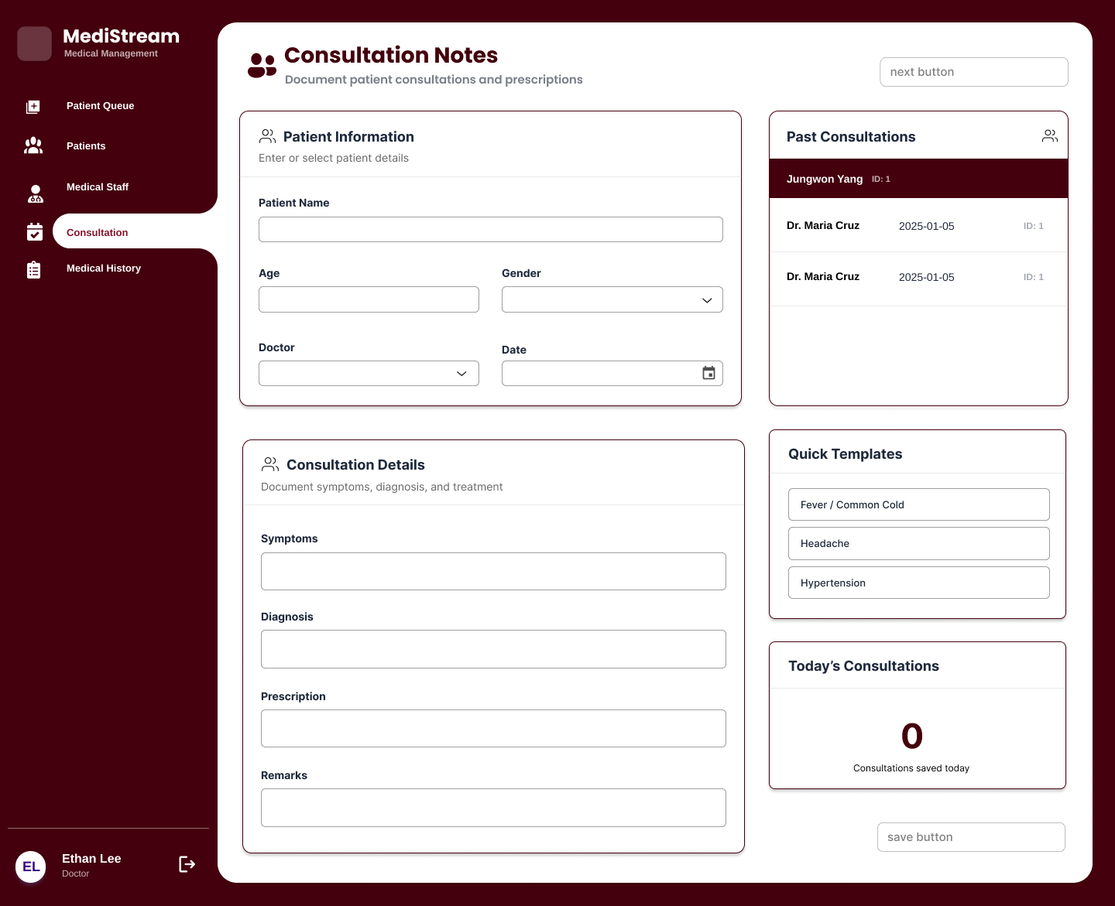
Consultation Notes

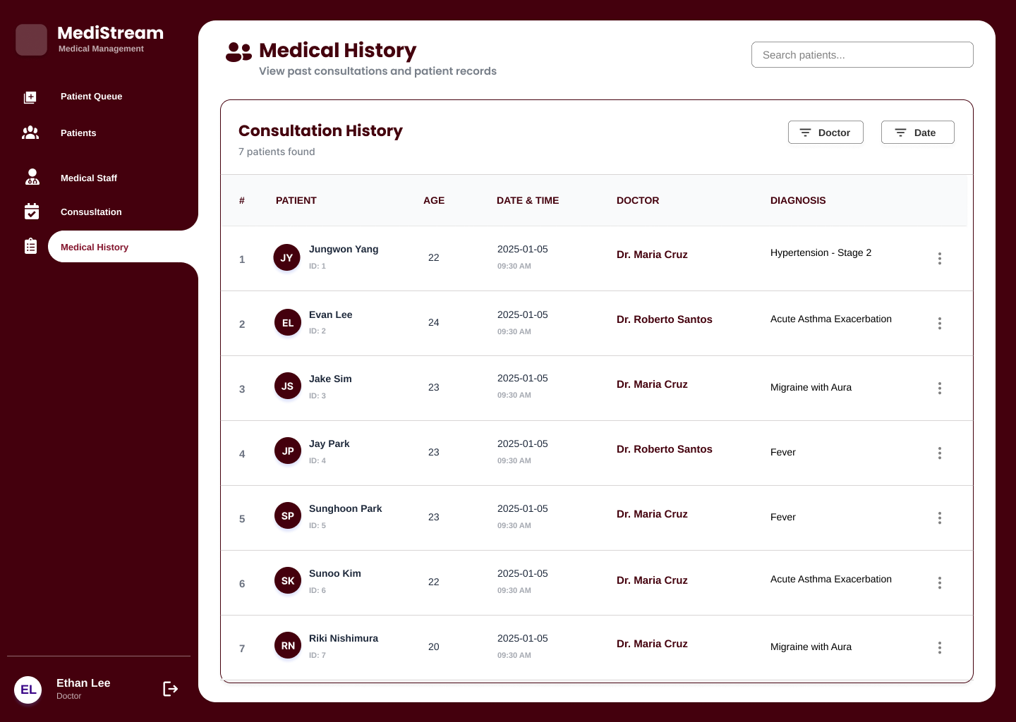
Medical History

7.2 Mobile Application Wireframes
(Only Patient side has mobile version)
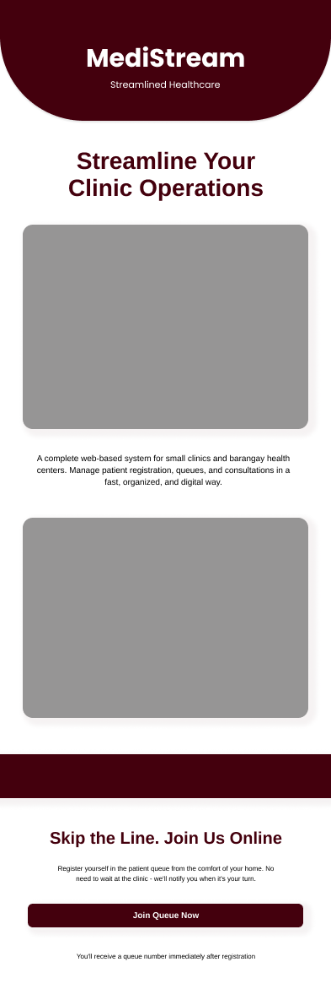
Landing Screen
Queue Dashboard
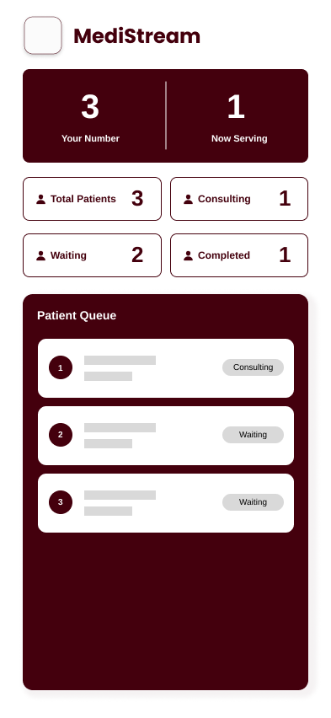
Queue Form
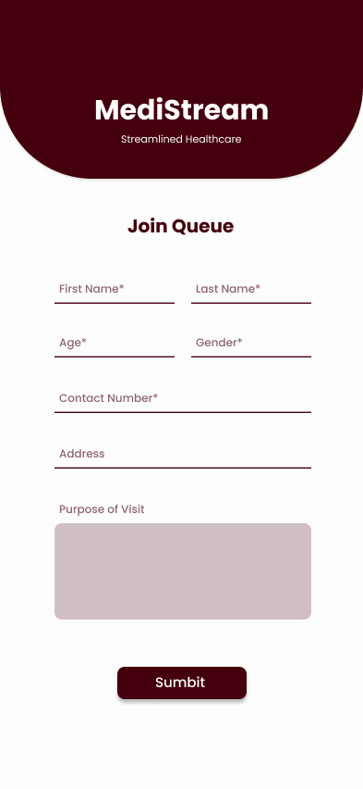

Mobile-Specific Features:
- Touch-optimized buttons (min 44x44px)
- Gesture support (swipe, pull-to-refresh)
- Offline caching for product images
- Bottom navigation for main actions
- Simplified forms for mobile input
Design System:
- Colors: Primary (#44000D)
- Typography: Inter font family, responsive sizing
- Spacing: 8px grid system
- Components: Consistent buttons, inputs, cards, modals
- Responsive: Mobile-first approach, breakpoints at 640px, 768px, 1024px

8.0 PLAN
8.1 Project Timeline
Phase 1: Planning & Design (Week 1-2)
Week 1: Requirements & Architecture
Day 1-2: Project setup and documentation
Day 3-4: Complete FRS and NFR
Day 5-7: System architecture design

Week 2: Detailed Design
Day 1-2: API specification
Day 3-4: Database design
Day 5-6: UI/UX wireframes
Day 7: Implementation plan finalization

Phase 2: Backend Development (Week 3-4)
Week 3: Foundation
Day 1: Spring Boot setup with dependencies
Day 2: Database configuration and entities
Day 3: JWT authentication implementation
Day 4: Staff registration with Staff ID
Day 5: Patient CRUD operations

Week 4: Core Features
Day 1: Queue management
Day 2: Consultation logging
Day 3: Patient history and search
Day 4: Staff management (Admin)
Day 5: Error handling and API documentation

Phase 3: Web Application (Week 5-6)
Week 5: Patient-Facing Features
Day 1: React setup with TypeScript
Day 2: Patient registration page
Day 3: Returning patient check-in page
Day 4: Queue display page
Day 5: API integration

Week 6: Staff-Facing Features
Day 1: Staff login page
Day 2: Queue dashboard
Day 3: Consultation form
Day 4: Patient history view
Day 5: Admin staff management

Phase 4: Mobile Application (Week 7-8)
Week 7: Android Foundation
Day 1: Android Studio setup and project structure
Day 2: Landing screen
Day 3: Patient registration screen
Day 4: Queue status screen
Day 5: API service layer

Week 8: Complete Mobile App
Day 1: Patient form UI
Day 2: UI polish and animations
Day 3: UI polish and animations
Day 4: Testing on emulator/device
Day 5: APK generation and documentation

Phase 5: Integration & Deployment (Week 9-10)
Week 9: Integration Testing
Day 1: End-to-end testing across platforms
Day 2: Bug fixes and optimization
Day 3: Security review
Day 4: Performance testing
Day 5: Documentation updates

Week 10: Deployment
Day 1: Backend deployment (Railway/Heroku)
Day 2: Web app deployment (Vercel/Netlify)
Day 3: Mobile APK distribution
Day 4: Final testing
Day 5: Project submission
Milestones:
- M1 (End Week 2): All design documents complete
- M2 (End Week 4): Backend API fully functional
- M3 (End Week 6): Web application complete
- M4 (End Week 8): Mobile application complete
- M5 (End Week 10): Full system deployed and integrated
Critical Path:
- Authentication system (Week 3)
- Patient registration & queue generation (Week 3-4)
- Consultation logging (Week 4)
- Staff dashboard (Week 6)
- End-to-end testing (Week 9)
Risk Mitigation:
- Start with simplest working version of each feature
- Test integration points early and often
- Keep backup of working versions
- Focus on core functionality before enhancements

